How to Do the Medical Terminology Assignment

I. Find an Article

1. Go to the library’s web page at http://library.mildred-elley.edu/

2. Click on the Ebsco link. Type in mecollege for the username and nursing03 for the password.



3. Search for a disease condition. Be specific with regard to the organ system or tissues affected. If you cannot think of a disease condition, go to google.com and search for diseases. Avoid articles that deal with drug testing.

4. Browse the articles in your results list. Once you have selected an article with enough words, open and print the article using the pdf as shown in the example below.



II. Create an APA Style Document for Your Word List

1. Open Microsoft Word. Create a new, blank document.



2. Select the font type. From the font menu, select Times New Roman size 12.

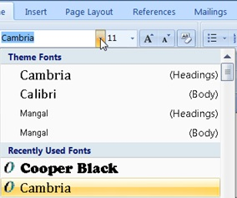
Times New Roman

3. Select the font size. From the line and paragraph spacing menu, select “2.0”
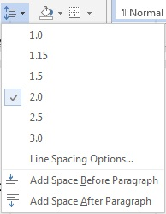
4. Add a header. To do this, double-click anywhere in the top one inch margin of the page. The appearance of a dotted line (shown here) indicates that the header region is active.

On the header and footer design menu at the top of the page, check the “different first page” box (shown here).

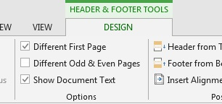

5. Insert a page number. Click on the insert ribbon (top left of the screen).



Then click on “Page Number” / “Top of Page” / “Plain Number Three” as shown here.

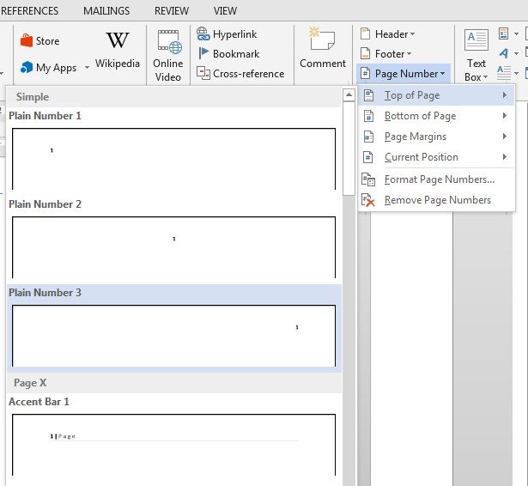

6. Page number “1” will appear. Without moving the mouse pointer, type Running head: MEDTERMS and press the TAB key on your keyboard twice. This will push the header to the left margin. Your header region on page one should now look like this:



7. Select the header and page number.

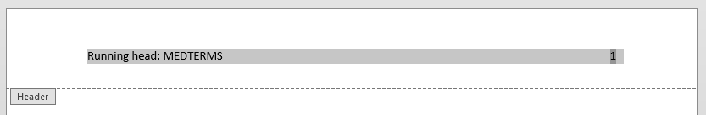

8. Change the font type and size to Times New Roman size 12 as you did in steps 2 and 3.

Your finished header should look like this:



9. Double-click anywhere below the dashed line to close the header region.

10. Add a second page to your document. Hold down the Enter key on your keyboard until a second page is added.

11. Create a header on the second page. Double-click in the top one-inch margin of the second page. The header region becomes active when the dotted line appears.

12. Insert a page number. Click on the insert ribbon (top left of the screen).

Then click on “Page Number” / “Top of Page” / “Plain Number Three” as shown here.

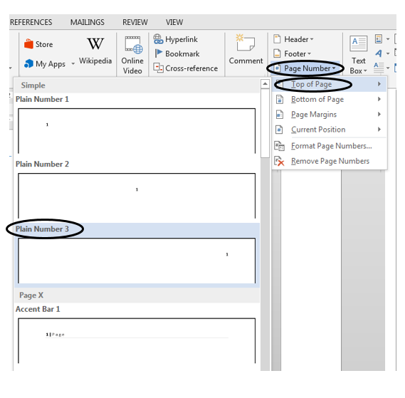
13. Page number “2” will appear. Without moving the mouse pointer, type MEDTERMS and press the TAB key on your keyboard twice. This will push the header to the left margin. Your header region on page two should now look like this:



14. Select the header text and page number as shown here:

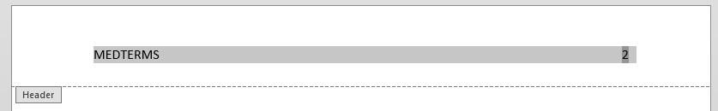

15. Change the font of the header and page number to Times New Roman as you did in steps two and three. Your finished header should look like this:



Your headers and page numbers are now complete.

III. Create a Cover Page.

1. Place the mouse pointer at the beginning of the first page, on the first line. Press the enter key on your keyboard four times.

2. Type “Medical Terminology Assignment” and press the enter key.

3. Type your name and press the enter key.

4. Type “Mildred Elley College. You should have three lines that look like this:

Medical Terminology Assignment
Your Name
Mildred Elley College

5. Select all three lines and click the center align button (shown here).



7. Your finished cover page should now look like this:


IV. List, Define and Label Your Medical Terms

Each word that you list will be followed with a definition, a breakdown of the word parts and labels for the word parts. At the end of each word entry, you must include a brief citation of the article from which the word was taken.

The following is an example of how a word, its definition, word parts, labels and in-text citation should look:

1. Osteoarthropathy. Disease of the bone and joint.
oste / o / arthr / o / pathy
WR CV WR CV S (Williams, 2011)

When you have finished you will have twenty words, each formatted as in the above example.

V. Create a References Page.
At the end of your paper, you must include a references page which is a list of the sources you used for this assignment. It should be in alphabetical order by the author’s last name. A sample of an APA style references page is included at the end of this guide.

FORMAT FOR RESOURCES IN REFERENCE LIST:

- Book
Author. (Year of publication). Title. City of publication: Publisher.

Summers, A. (2000). The arrogance of power. New York: Viking.
**If citing an e-book retrieved from a website, add the following after the publisher: Retrieved from http://www... (website URL)

- Journal Article
Author(s). (Year). Title of article. Title of Journal, volume (issue number), pages.

Weiss, M. (2011). The use of social media sites data by business organizations in their relationship with employees. Journal of Internet Law, 15(2), 16+.
**If retrieved from a website, include the following after the pages: Retrieved from http://www…
(website URL)
**If retrieved from an online database, include DOI (digital object identifier) information after the pages, if it is available:
ex. doi:9876/1234567890.

- Web Site
Author. (Year). Title of page. Retrieved from _____________________
website URL

Wax, A. (2010). Understanding lung cancer. Retrieved from http://www.webmd.com

If no author: Lung cancer prevention. (2010). Retrieved from http://www.cancer.gov
**Include retrieval date information only if you are citing a wiki (ex. Wikipedia), or other type of source that is regularly changing.

References

Dolch, N. & Douglass, K. (1986). Does the teaching of writing actually improve writing? Free Inquiry Into Creative Sociology, 14(1), 89-92.
Galvan, J. (2009). Writing literature reviews fourth edition. Glendale, CA: Pyrczak.
Mason, L. H., Benedek-Wood, E. & Valasa, L. (2009). Teaching low-achieving students to self-regulate persuasive quick write responses. Journal of Adolescent and Adult Literacy, 53(4), 303-312. doi: 10.1598/JAAL.53.4.4

